

Factory Resetting and Accessing
Palo Alto Firewalls


Rui Zhao, CCNA
Purpose:

The purpose of accessing and factory resetting a Palo Alto PA-220 firewall is to reboot and restore the firewall into its original factory settings, ensuring removal of prior configurations, policies, and user data.

Background Information:

A firewall is a network security device that separates trustworthy networks and untrustworthy networks, regulating the incoming and outgoing network traffic based on security rules that are implemented by the user. They are essential tools, used to shield consumers from unauthorized access, threats, and activities. They serve as gatekeepers and decide whether to permit information in or not.

Types of notable firewalls are packet proxy, filtering, stateful, web application, unified threat management, next generation, AI-powered, virtual, and cloud native.

Palo Alto Networks, founded by Nir Zuk in 2005, is a cybersecurity company with headquarters in Santa Clara California. They produce advanced firewalls for security reasons.

By implementing firewalls, one can enhance their security of their networks significantly and also protect sensitive data. Firewalls give protection in the face of increasing cyber threats. Selection of firewall requires careful consideration of network performance, scalability, and ease of management.

Palo Alto Networks has founded the Cyber Threat Alliance with notable companies like Fortinet, McAfee, and Norton Life Lock in order to improve cybersecurity by sharing cybersecurity knowledge. They will soon have more members like Cisco, Check Point, Juniper Networks, and Sophos.

The Palo Alto PA-220 is a firewall that offers “Advanced Security at Scale” released by Palo Alto Networks. The firewall ensures security performance, threat prevention, and SSL decryption, meaning that customers can go onto the cloud without attacks coming from different environments like cloud network. The PA-220 series delivers full PAN-OS capabilities and is equipped with increased port density and a built-in resiliency via dual power adapters. The Palo Alto has also implemented noise cancellation and increased reliability, which must be ideal in small offices and remote places.

The PA-220 version of Palo Alto has scored highest security effectiveness score in the 2019 NSS Labs NGFW Test Report, blocking 100% of evasions. The said firewall identifies and categorizes all applications with full layer 7 inspection.

The PA-220 specifications have 1.62” H x 6.29” D x 8.07” W dimensions, weighing a total of 3.0 lbs on device itself alone. The firewall throughput of HTTP/appmix outputs 545/535 Mbps and has a max session of 64,000 sessions along with 4,200 sessions per second.

A factory reset is the process where you restore a device to its original state when it was first delivered. The process will erase all of your personal data, including setting configurations, changes to the device, and user data. It’s also useful to fix underlying problems and troubleshoot them by erasing them all entirely. Additionally, if you would like to decide to sell your used product, you must factory reset your device. Do note that in this process, it is advised to back up potential configurations or user data as they will be lost in this process. Make sure that your device is properly plugged in, charging with sufficient amount of battery to ensure no corruption with your device.

Lab Summary:

We were ultimately able to set up the Palo Alto firewalls and boot up their interfaces using PuTTY. We ran through with maintenance mode to factory reset the firewall because the previous owner’s firewall login credentials were unknown.

Lab Commands:


Make sure that the personal computer is consoled into the switch of Firewall.
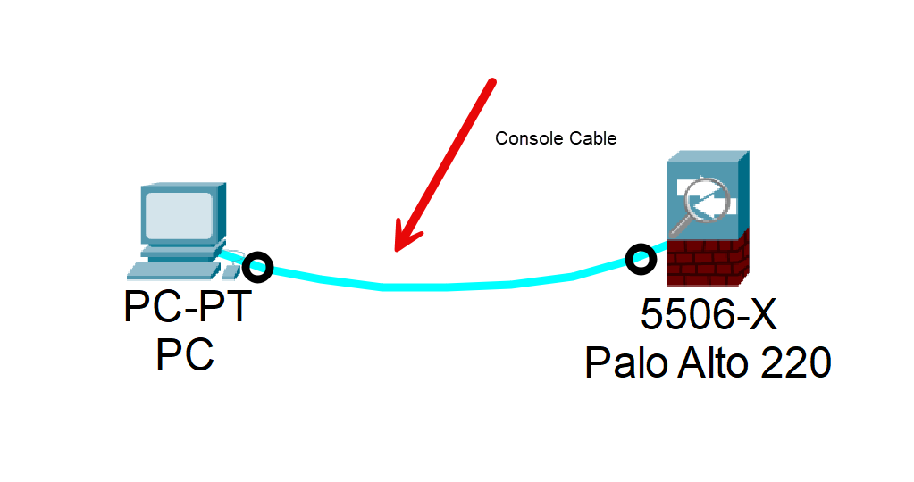


From Windows Start, type in Check firewall status and open the application.
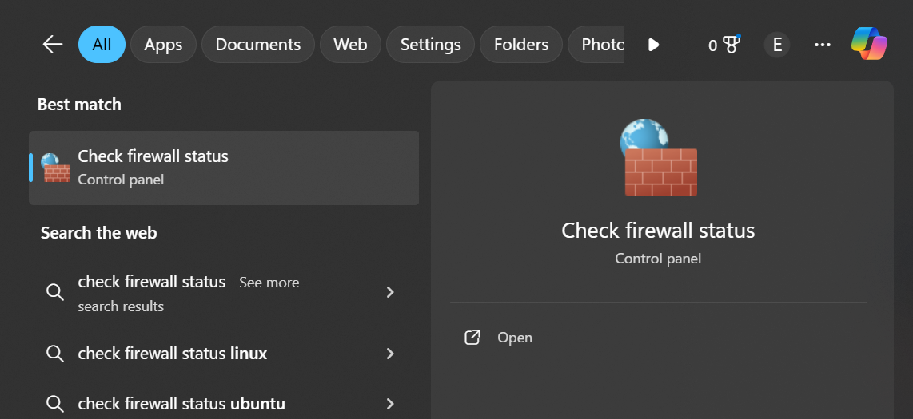

Navigate to Turn Windows Defender Firewall on or off.

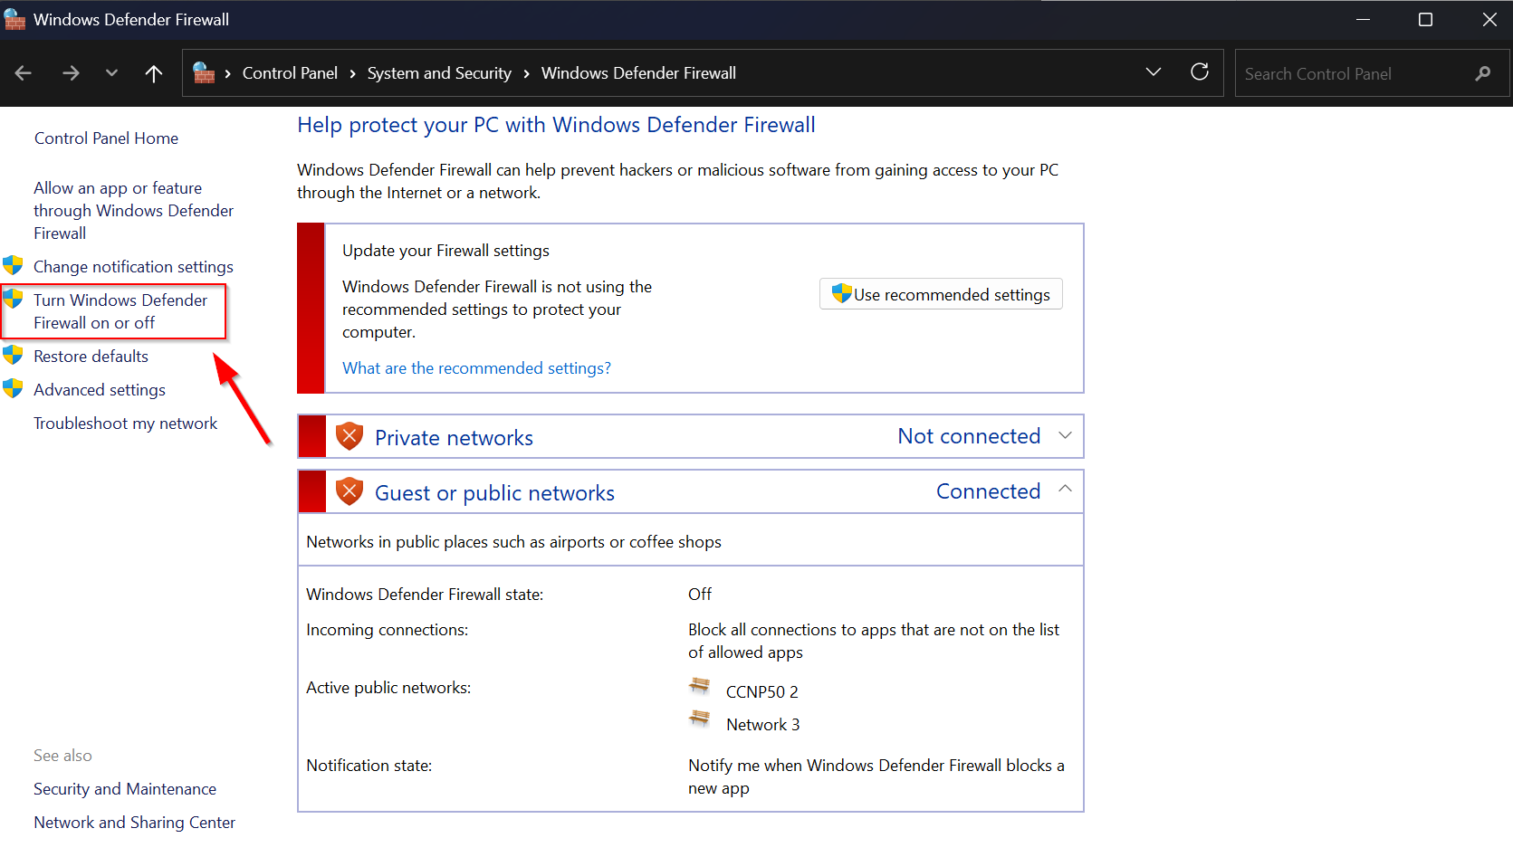

Make sure firewall is turned off and press OK.

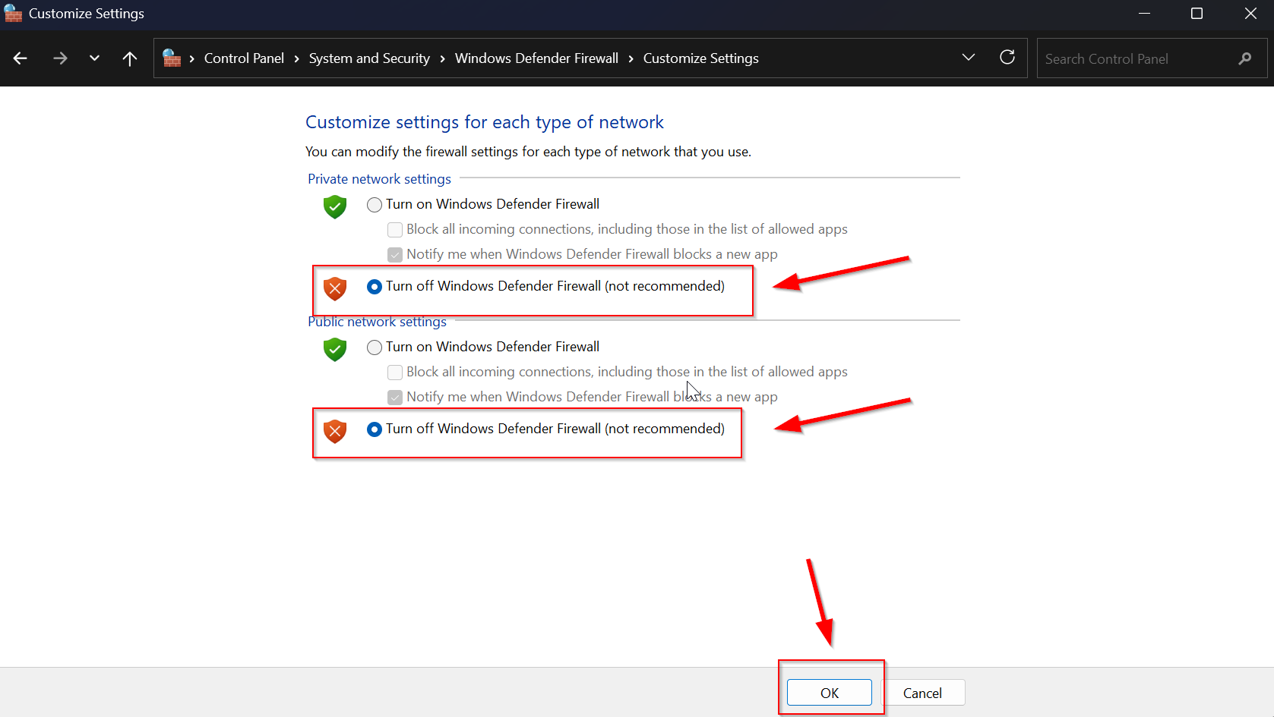

Open up PuTTY. Select “Serial” in Connection type and then under Connection/SSH, click “Serial”
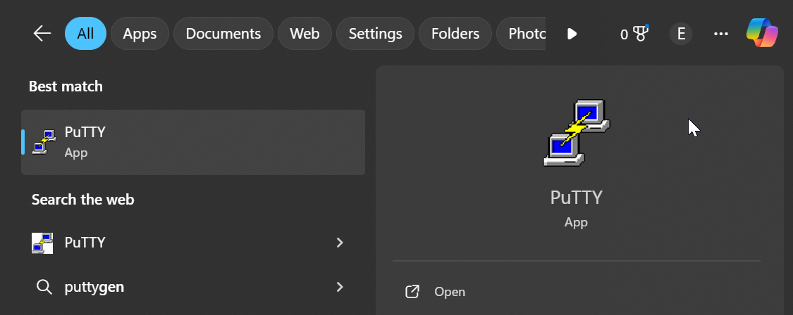

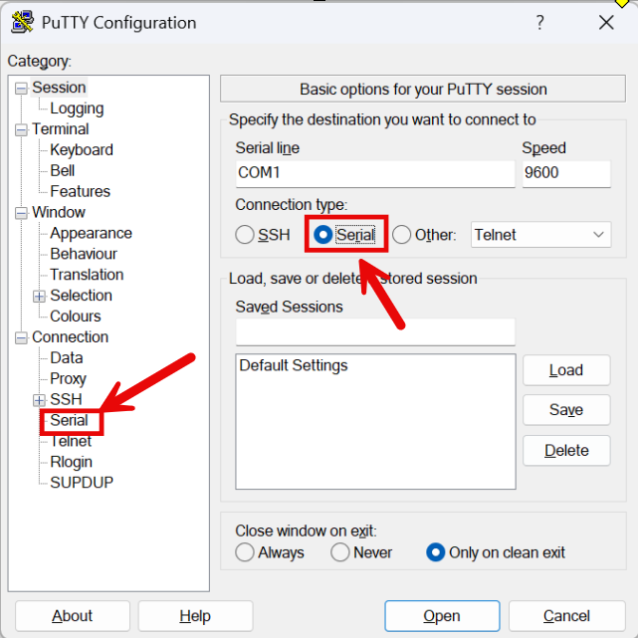


Set serial line configuration to 9600 baud speed, 8 data bits, 1 stop bits, Parity: None, and Flow control: None
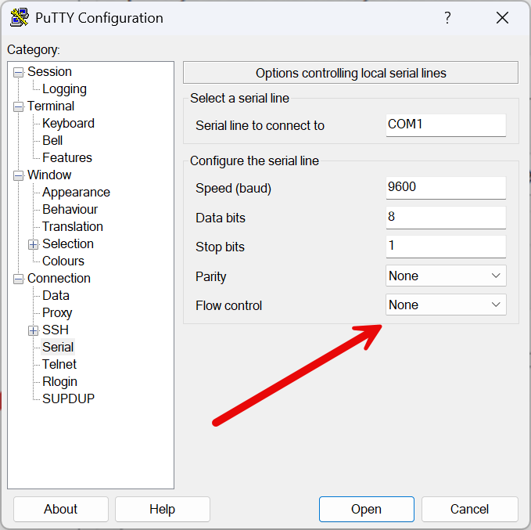

Click open and enter the PuTTY Maintenance Recovery Tool
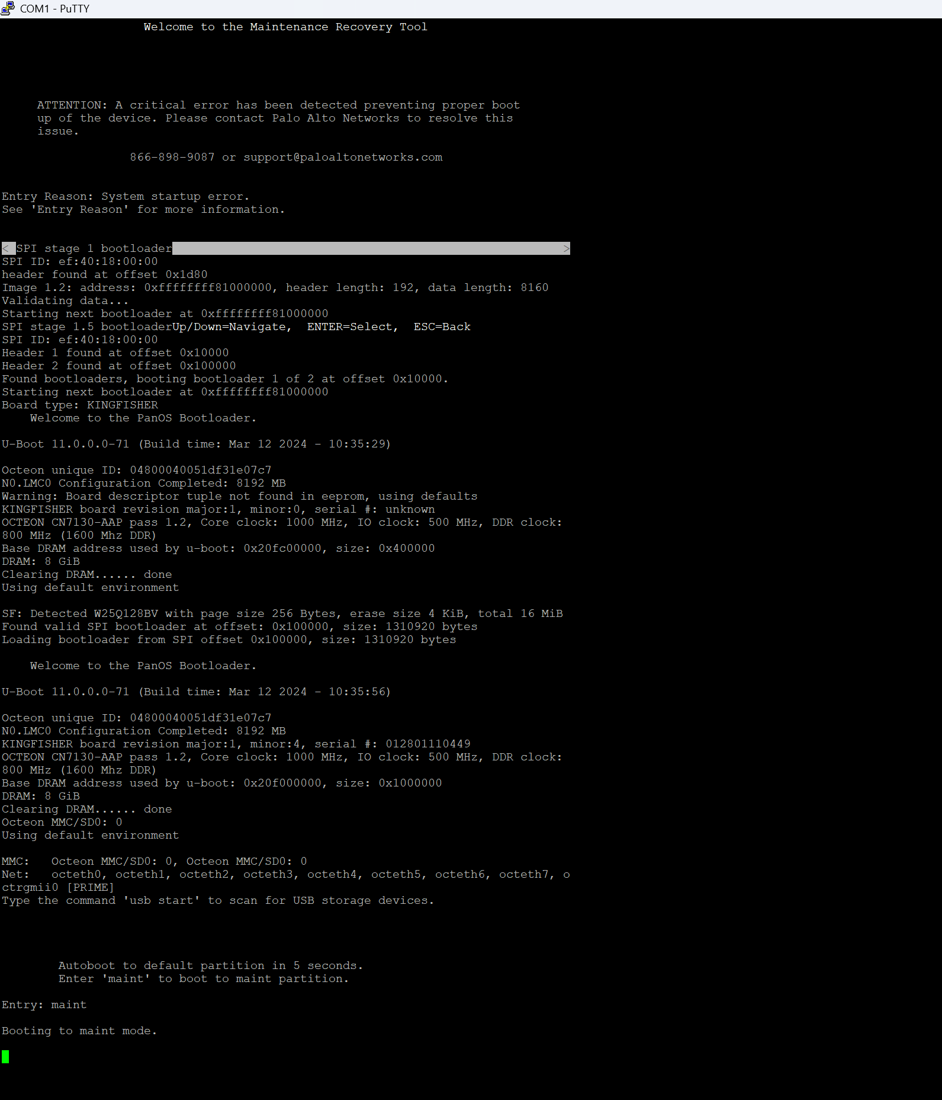


When prompted “Autoboot to default partition in 5 seconds. Enter ‘maint’ to boot to maint partition”, type “maint” on your keyboard. It should show up after “Entry: “
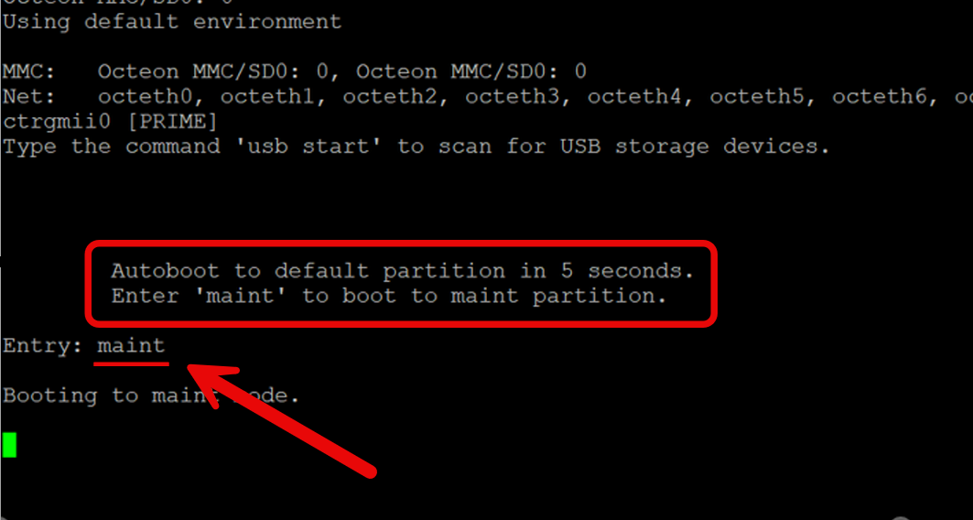

You have now accessed the Maintenance Recovery Tool. In this menu, use arrow keys (down/up) to navigate to “Factory Reset” and press Enter.

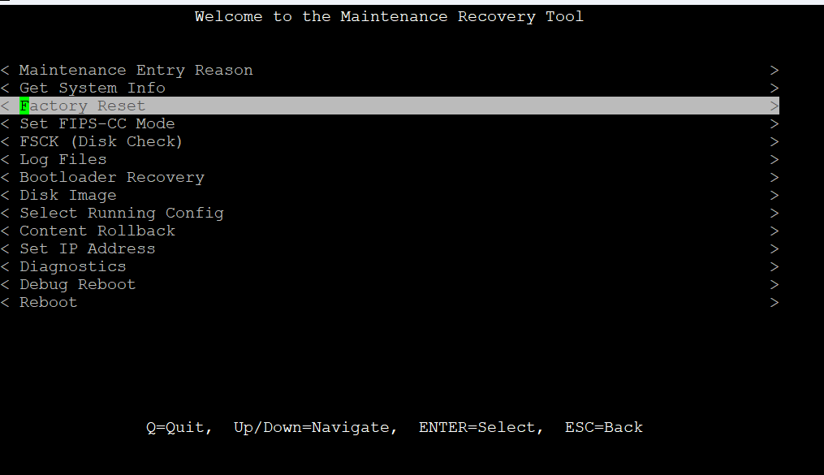


Again, using arrow keys (up/down), navigate to “< Factory Reset” and press Enter.
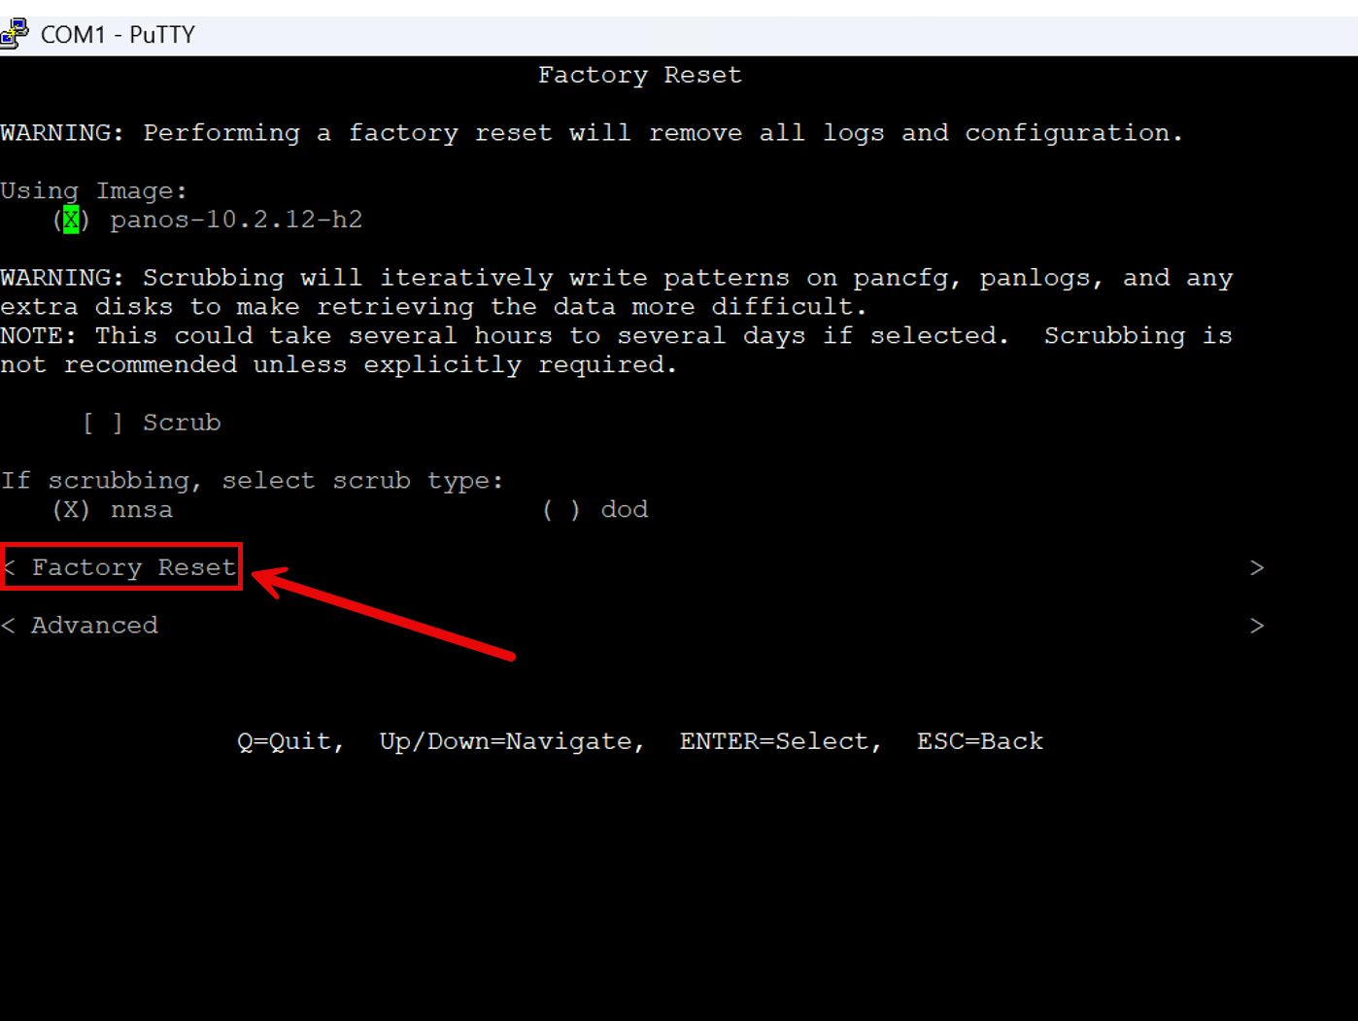

Your screen should look like this. Your factory reset is in process. Wait till factory reset status indicates success.


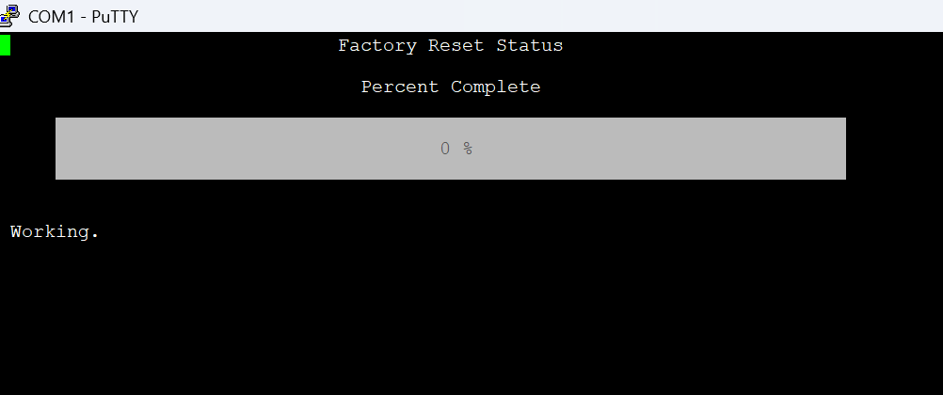
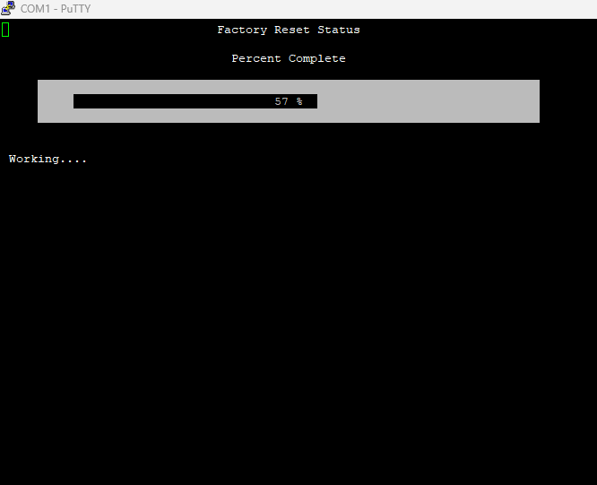

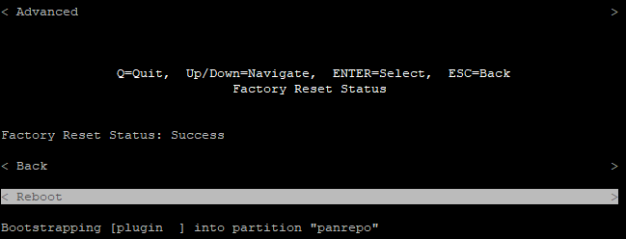

Once you have arrived at the “Factory Reset Status: Success” screen, use arrow keys (up/down) and press Enter on “Reboot.” When you arrive at the maint entry screen, do NOT click anything.

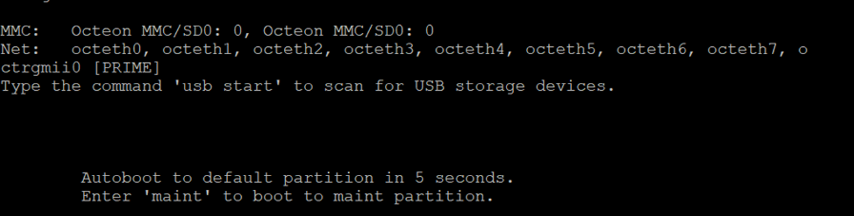

The login screen should soon show up. Type in user “admin” and password “admin.” If prompted to enter old password, type in “admin.” Then, when prompted Enter new password, type in your new password. Note: new password length must be 8 letters or more, at least 1 uppercase letter, and at least 1 number. Confirm your new password and you should be logged in. Make note of your new login information.

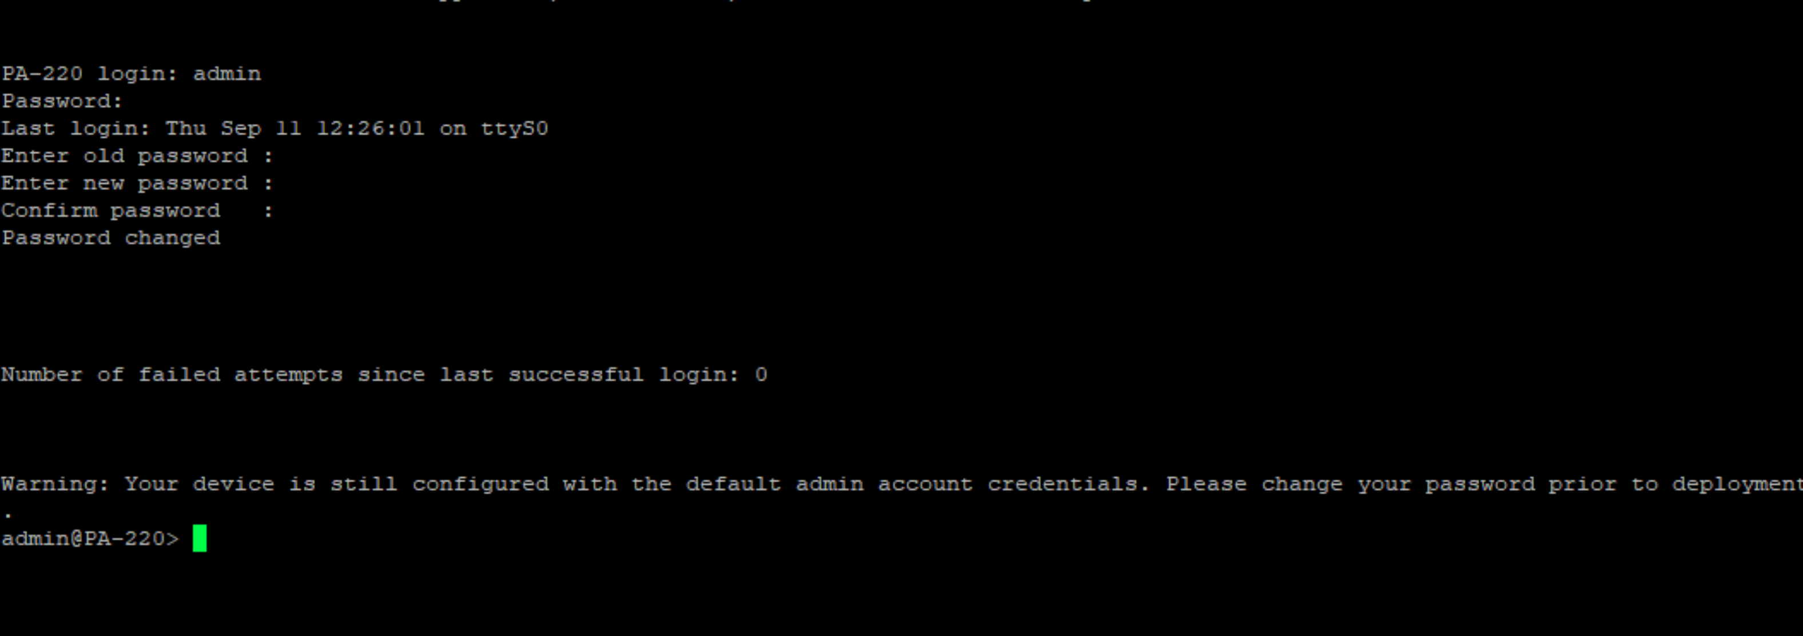


Connect your device to the firewall with ethernet cables.
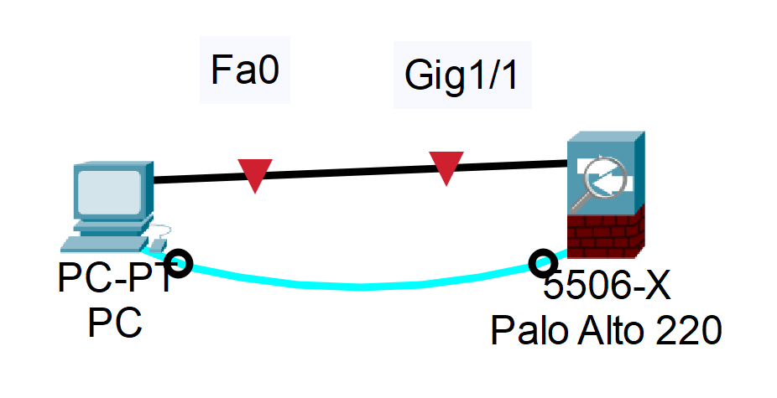
On your browser, enter https:// followed by your firewall’s ip address (Ex: 192.168.1.1). Note: when entering the website, a security browser may appear to take you off the site. Depending on browser (like Chrome), if prompted a safety concern, click on Advanced then proceed to your firewall’s ip address website.




Your screen should look like this. Using your username (admin) and your new password, log in to the firewall domain.

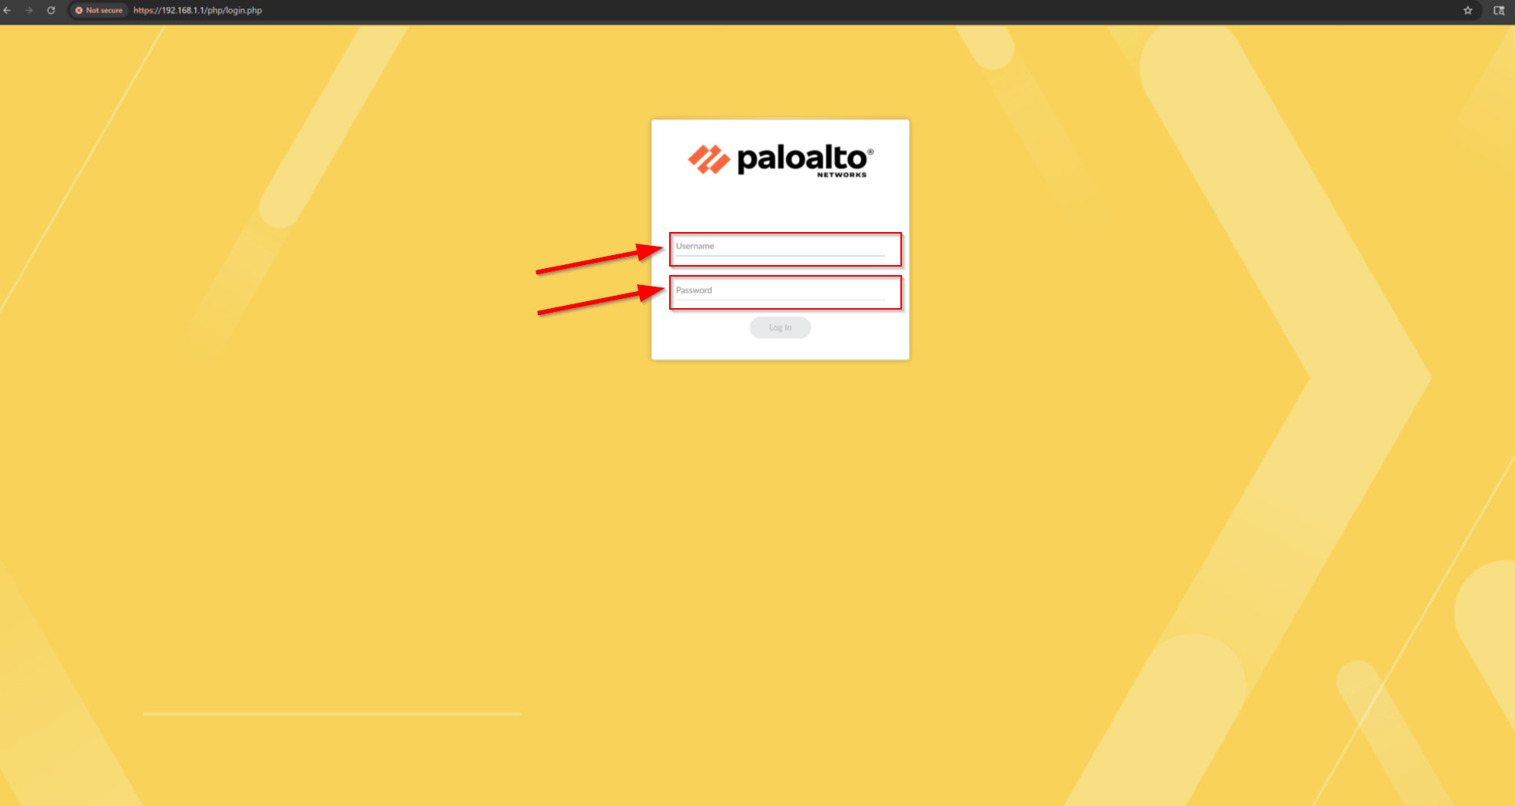

Once you have logged in, your screen should look like this:

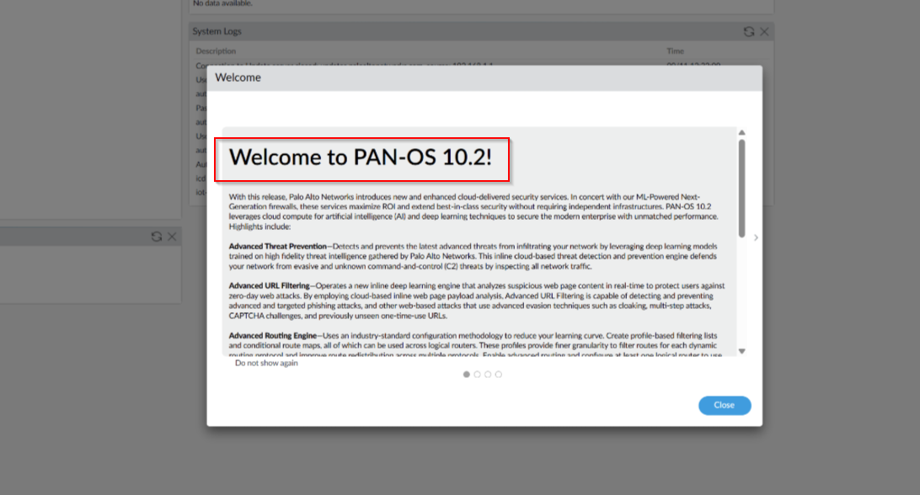

You have successfully logged into PAN-OS 10.2, the firewall domain.


Problems:

During the factory reset process, we were unable to access our user login credentials. Furthermore, we couldn’t enter maintenance mode due to potential problems with the firewall device. Each time when the interface prompted us to type “maint” to enter maintenance mode, it froze.

However, after meticulously rebooting the firewall and swapping out PA-220 devices, we were ultimately able to access the maintenance menu and successfully perform the factory to reset the firewall.

Conclusion:

In conclusion, the lab has introduced hands-on experience of managing a Palo Alto PA-220 firewall. Despite the challenges encountered during the process, they turned into learned experiences and knowledge within the debugging process as we were able to attempt many techniques to solve our problem. This lab has strengthened factory resetting fundamentals as well as emphasizing the importance of record keeping of login credentials and records.




